Practical File
of

Fundamentals of C Programming
(24CSE0107)

Batch-2026

Bachelor of Engineering (CSE)



Submitted By  Student Name: Rajveer Singh Kaler  Roll No: 2510990178  Group No. 1, Sem: 2nd, BE (CSE) 2026  Chitkara University, Punjab, 140401  India | Submitted To  Faculty Name: Mr. Vibhu Sharma  Designation: Assistant Professor, CSE  Chitkara University, Punjab, 140401  India

Department of
Computer Science and Engineering,
Chitkara University School of Engineering and Technology,
Chitkara University, Punjab, India

INDEX

S.No. | Practical | Page No. | Signature
1. | Install C compiler (GCC/Code::Blocks), set up IDE, compile and run the first "Hello, World!" program.
2. | Write a Program to show the use to input (Scanf)/output (Printf) statements and block structure of C-program by highlighting the features of "stdio.h".
3. | Write a program to add two numbers and display the sum.
4. | Write a program to calculate the area and the circumference of a circle by using radius as the input provided by the user.
5. | Write a Program to perform addition, subtraction, division and multiplication of two numbers given as input by the user.
6. | Write a program to evaluate each of the following equations.  (i) V = u + at. (ii) S = ut+1/2at² (iii) T=2*a+√b+9c (iv) H=√b²+p²
7. | Write a program to swap two variables:  a) By using temporary variable.  b) Without using temporary variable
8. | Write a Program to find the greatest among three numbers using:  - Conditional Operator  - If-Else statement
9. | Write the following programs using switch case statement:  - To check that an input alphabet is vowel or consonant  - To check whether a number is positive, negative or zero
10. | Write a program using while loop to print the sum of first n natural numbers.
11. | Write a program to check a number is Armstrong or not using For loop.
12. | Write the program to count the digits in a number and then print the reverse of the number also.
13. | Write a program to generate the Fibonacci series.
14. | Write a program to print the following patterns:  a)  *  * *  * * *  * * * *  * * * * *  * * * * * *  b)  *  * *  * * *  * * * *  * * * * *  * * * * * *
15. | Write the program to print the following pattern:  1 2 3 4 5 6  2 4 6 8 10 12  3 6 9 12 15 18  4 8 12 16 20 24  5 10 15 20 25 30  6 12 18 24 30 36
16. | Write a program to check that the given number is prime, Armstrong or perfect using the concept of functions.
17. | Write a program to calculate the area and circumference of a circle using functions.
18. | Write a program to swap two variables using the concept of call by value and call by reference.
19. | Write a program to perform the following operations on 1D-Array:  - Insert  - Update  - Delete  - Display  - Search
20. | Write a program to calculate the sum of array elements by passing it to a function.
21. | Write a program to show the use of passing pointer as arguments to the functions.
22. | Write a program matrix multiplication using the concept of 2D array
23. | Write a program to transpose a given matrix.
24. | Write a program to find the factorial of a number by using the concept of recursion.
25. | Write a menu driven C program to show the use of in-built string functions like strlen, strcat, strcpy, strcmp, strrev etc.
26. | Write a Program in C to display the total number of appearances of a substring provided as input by the user in a given string.
27. | Write a program to display the sum of the digits of a number by using the concept of recursion.
28. | Write a C program to add two distances in inch & feet using the concept of structures.
29. | Write a C program to add two complex numbers using the concept of structures in C.
30. | Write a program in C to store the information of five employees using both concepts i.e. array of structure and array within structure.
31. | Write a Program in C to find and replace a specific string in a file and also display the total number of appearances of that string.

Experiment No. 1.
Aim: Install C compiler (GCC/Code::Blocks), set up IDE, compile and run the first "Hello, World!" program.
Concept Used: Learning about git and C and implementing them to make a simple program.

Program:
C Program-
#include <stdio.h>

int main(){
printf(“Hello World!”);
return 0;
}
Git commands-
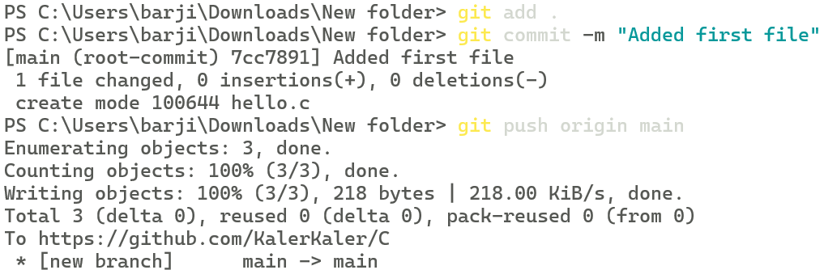

Output Screenshot:

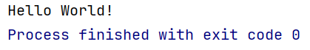

Experiment No. 2
Aim: Write a Program to show the use to input (Scanf)/output (Printf) statements and block structure of C-program by highlighting the features of "stdio.h".
Concept Used: The fundamental concept is the implementation of Standard Input/Output (I/O) Streams via the <stdio.h> library, which enables a program to bridge the gap between user data and memory storage. This interaction is housed within a Structured Block, where curly braces define the scope of the main() function to ensure the compiler processes instructions in a logical, sequential order.
Program:

#include <stdio.h>

int main() {

int number;
printf("Enter your birth month\n");
scanf(" %d", &number);
printf("Thanks. I will remember your birthday is in month %d.", number);

return 0;

}

Output Screenshot:
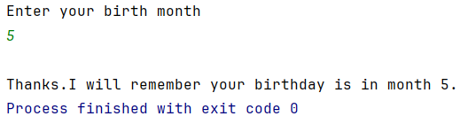

Experiment No. 3
Aim: Write a program to add two numbers and display the sum.

Concept Used: The program utilizes variable declaration to reserve memory for numerical data and uses standard input/output functions to interact with the user via the console. It then applies the arithmetic addition operator to calculate the result and stores it using the assignment operator before displaying the final sum.

Program:

#include <stdio.h>

int main() {

int num1,num2, sum=0;
printf ( "Enter number 1: ");
scanf( "%d", &num1) ;
printf( "Enter number 2: ");
scanf ( "%d", &num2) ;|
sum = num1 + num2;
printf( "The sum of %d and %d is: %d\n", num1, num2, sum) ;
}

Output Screenshot:

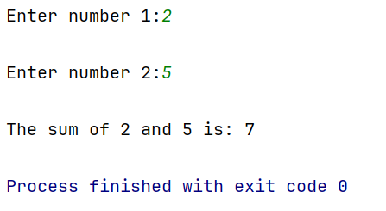

Experiment No. 4
Aim: Write a program to calculate the area and the circumference of a circle by using radius as the input provided by the user.

Concept Used: To calculate these properties, the program uses floating-point data types to handle decimal values and preprocessor directives or constants for precision. The core logic relies on arithmetic expressions to implement the geometric formulas, which are then output using formatted strings in the printf function.

Program:

#include <stdio.h>

int main(void) {
float radius, area=0, circumference=0;
float pi=3.14;
printf("Enter radius of the circle\n");
scanf("%f", &radius);
circumference=2*pi*radius;
area=pi*radius*radius;
printf("Area of the circle is %.2f and the Circumference is %.2f.", area, circumference);
return 0;
}

Output Screenshot:
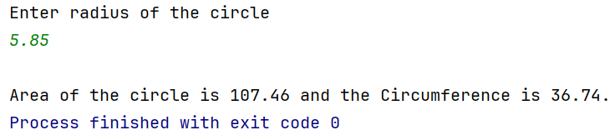

Experiment No. 5
Aim: Write a Program to perform addition, subtraction, division and multiplication of two numbers given as input by the user.

Concept Used: The program utilizes arithmetic operators to perform basic mathematical computations on user-provided input stored in variables. It relies on standard input/output functions to capture the operands and display the resulting values for each operation in a formatted structure.

Program:

#include <stdio.h>

int main(void) {
int num1,num2,choice;
float result;
printf("Enter the first number\n");
scanf("%d",&num1);
printf("Enter the second number\n");
scanf("%d",&num2);
printf("Which operation do you want to perform?\nEnter 1 for addition, 2 for substraction, 3 for multiplication, 4 for division\n");
scanf("%d",&choice);
switch(choice) {
case 1:
result=num1+num2;
break;
case 2:
result=num1-num2;
break;
case 3:
result=num1*num2;
break;
case 4:
result=(float)num1/num2;
break;
default:
printf("Invalid choice");
}
printf("The result of the operation is %.2f",result);
}

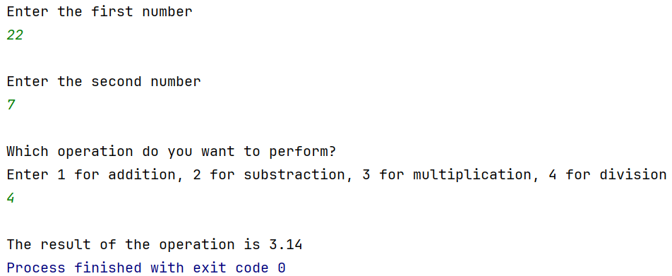
Output Screenshot:

Experiment No. 6
Aim: Write a program to evaluate each of the following equations.
(i) V = u + at. (ii) S = ut+1/2at² (iii) T=2*a+√b+9c (iv) H=√b²+p²

Concept Used: The program uses preprocessor directives to include the math library for square root and power functions. It processes user-provided variables through arithmetic expressions to solve standard kinematic and geometric formulas.

Program:

#include <stdio.h>
#include <math.h>

int main() {
double initial_velocity, acceleration, time_duration;
double variable_b, variable_c, variable_p;

printf("Enter initial velocity (u), acceleration (a), and time (t): ");
scanf("%lf %lf %lf", &initial_velocity, &acceleration, &time_duration);
printf("Enter values for b, c, and p: ");
scanf("%lf %lf %lf", &variable_b, &variable_c, &variable_p);

double final_velocity = initial_velocity + (acceleration * time_duration);
double displacement = (initial_velocity * time_duration) + (0.5 * acceleration * pow(time_duration, 2));
double result_t = (2 * acceleration) + sqrt(variable_b) + (9 * variable_c);
double hypotenuse = sqrt(pow(variable_b, 2) + pow(variable_p, 2));

printf("\nResults:\n");
printf("(i) Final Velocity (V) = %.2f\n", final_velocity);
printf("(ii) Displacement (S) = %.2f\n", displacement);
printf("(iii) Result (T) = %.2f\n", result_t);
printf("(iv) Hypotenuse (H) = %.2f\n", hypotenuse);

return 0;
}

Output Screenshot:
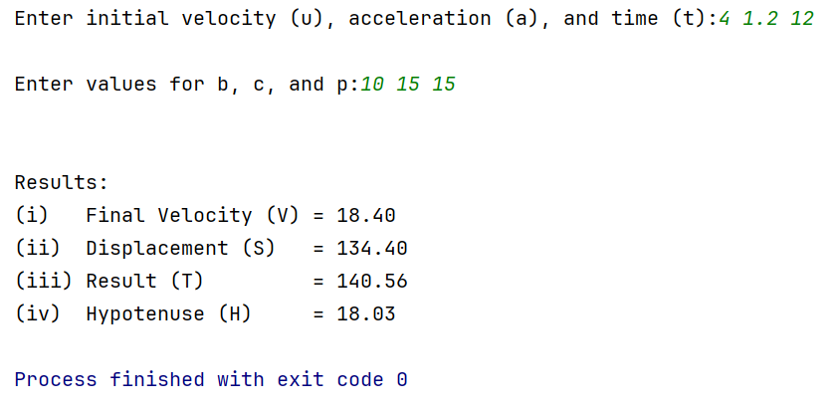

Experiment No. 7
Aim: Write a program to swap two variables:
a) By using temporary variable.
b) Without using temporary variable

Concept Used: Swapping with a temporary variable uses a buffer to preserve data by shifting values in a three-step cycle to prevent overwriting the original input. Swapping without a temporary variable relies on arithmetic accumulation and subtraction to derive and store both values within the existing memory locations.

Program:

#include <stdio.h>

int main() {

int num1,num2,buffer;
printf("Enter number 1\n");
scanf("%d",&num1);
printf("Enter number 2\n");
scanf("%d",&num2);
printf("Using swap variable\n");
buffer = num1;
num1 = num2;
num2 = buffer;
printf("After swapping the variables\nnum1 = %d and num2 = %d\n",num1,num2);
printf("Without swap variable\n");
num1=num1+num2;
num2=num1-num2;
num1=num1-num2;
printf("After swapping back\nnum1 = %d and num2 = %d.", num1,num2);
}

Output Screenshot:

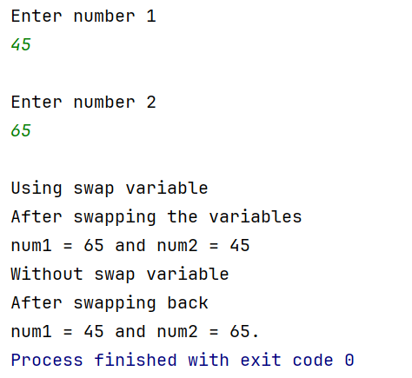

Experiment No. 8
Aim: Write a Program to find the greatest among three numbers using:
- Conditional Operator
- If-Else statement

Concept Used: The conditional operator uses nested ternary logic to evaluate multiple comparisons within a single line by returning the maximum value based on boolean truth. The if-else statement structures this logic into a hierarchical sequence of blocks to isolate the largest number through explicit conditional testing.

Program:

#include <stdio.h>

int main() {
int num1,num2,num3,largest;
printf("Enter three numbers separated by spaces\n");
scanf("%d %d %d",&num1,&num2,&num3);
printf("Using conditional operator:-\n");
printf("The biggest number is %d.\n",(num1>num2)?num1:(num2>num3)?num2:num3);
printf("Using If-Else\n");
if (num1>num2 && num1>num3) {
largest = num1;
}
else if (num2>num1 && num2>num3) {
largest = num2;
}
else {
largest = num3;
}
printf("The largest number is %d.",largest);
}

Output Screenshot:

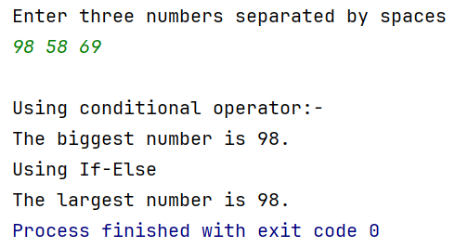

Experiment No. 9
Aim: Write the following programs using switch case statement:
- To check that an input alphabet is vowel or consonant
- To check whether a number is positive, negative or zero

Concept Used: The switch case statement evaluates a single expression against multiple constant values to execute the corresponding block of code efficiently. It uses case labels for matching and a default case to handle any inputs that do not meet the specified criteria.

Program:
#include <stdio.h>

int main() {
char alphabet;
int number;
printf("Enter an alphabet and a number: \n");
scanf(" %c %d", &alphabet, &number);
switch (alphabet) {
case 'a': case 'A': case 'e': case 'E':
case 'i': case 'I': case 'o': case 'O':
case 'u': case 'U':
printf("'%c' is a Vowel.\n", alphabet);
break;
default:
printf("'%c' is a Consonant.\n", alphabet);
}
switch (number > 0) {
case 1:
printf("%d is Positive.\n", number);
break;
case 0:
switch (number < 0) {
case 1:
printf("%d is Negative.\n", number);
break;
default:
printf("%d is Zero.\n", number);
}
break;
}
return 0;
}
Output Screenshot:

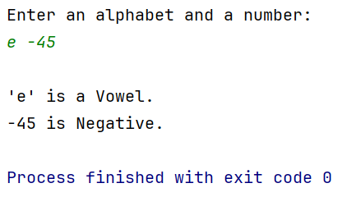

Experiment No. 10
Aim: Write a program using while loop to print the sum of first n natural numbers.

Concept Used: The while loop repeatedly executes an addition statement that accumulates the current value of a counter into a sum variable until a specified condition is met. It uses entry-controlled logic to update the counter and terminate the process once the number of iterations matches the user-provided value.

Program:

#include <stdio.h>

int main() {
int upper_limit,num=1,sum=0;
printf("Enter upper limit: \n");
scanf("%d",&upper_limit);
while (num<=upper_limit) {
sum+=num;
num++;
}
printf("The sum of first %d natural numbers is: %d\n",upper_limit,sum);
return 0;
}

Output Screenshot:

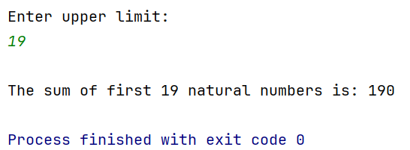

Experiment No. 11
Aim: Write a program to check a number is Armstrong or not using For loop.

Concept Used: The for loop iterates through each digit of the number by using the modulo operator to extract the remainder and the division operator to reduce the value. It calculates the power of each digit and adds it to an accumulator variable, which is finally compared to the original input to determine if it is an Armstrong number.

Program:

#include <stdio.h>
#include <math.h>

int main() {
int number,sum=0,temporary;
printf("Enter a three-digit number to check\n");
scanf("%d",&number);
temporary = number;
for (int i=0;temporary>0;i++) {
sum += pow(temporary%10,3);
temporary /=10;
}
printf((sum==number)?"This is an armstrong number.":"It is not an armstrong number");
return 0;
}

Output Screenshot:

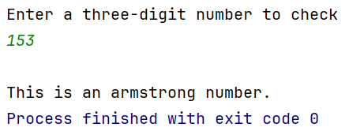

Experiment No. 12
Aim: Write the program to count the digits in a number and then print the reverse of the number also.

Concept Used: The program uses integer division within a loop to reduce the number and increment a counter until the value becomes zero. It simultaneously extracts the last digit using the modulo operator and appends it to a result variable multiplied by ten to reconstruct the number in reverse order.

Program:

#include <stdio.h>

int main() {
int length,number,rev_number;
printf("Enter a number\n");
scanf("%d",&number);
for (length=0;number!=0;length++) {
rev_number*=10;
rev_number+=number%10;
number/=10;
}
printf("The length of the entered number is %d\n",length);
printf("The reverse of the entered number is %d\n",rev_number);
return 0;
}

Output Screenshot:

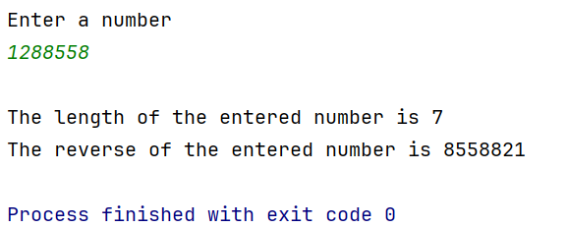
Experiment No. 13
Aim: Write a program to generate the Fibonacci series.

Concept Used: The program utilizes iterative reassignment within a loop to calculate the next term by adding the two preceding values. It relies on placeholder variables to shift the sequence forward, updating the first and second terms in each iteration to maintain the progression.

Program:

#include <stdio.h>

int main() {
int num1=0,num2=1,limit;
printf("Enter the limit till which to generate the series\n");
scanf("%d",&limit);
printf("The fibonacci series till %d is-\n",limit);
while(num1<=limit) {
num1=num1+num2;
num2=num1-num2;
printf("%d\n",num2);
}
}

Output Screenshot:
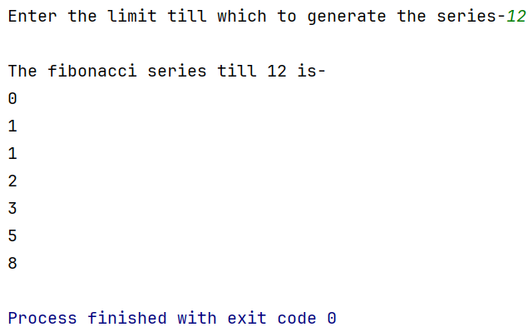

Experiment No. 14
Aim: Write a program to print the following patterns:
Concept Used: loops, nested loops, variables, increment/decrement, printf, conditionals

a)
*
* *
* * *
* * * *
* * * * *
* * * * * *

Program:

#include <stdio.h>

int main() {
int row;
printf("Enter the number of rows to generate\n");
scanf("%d", &row);
for (int i = 0; i < row; i++) {
for (int j = 0; j < i; j++) {
printf("* ");
}
printf("\n");
}
}

Output Screenshot:
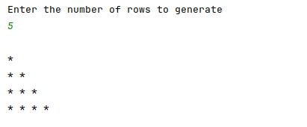

b)
*
* *
* * *
* * * *
* * * * *
* * * * * *

Program:
#include <stdio.h>

int main() {
int row;
printf("Enter the number of rows to generate\n");
scanf("%d", &row);
for (int i = 0; i < row; i++) {
for (int k = 0; k < row - i; k++) {
printf(" ");
}
for (int j = 0; j < i; j++) {
printf("*");
}
printf("\n");
}
}

Output Screenshot:
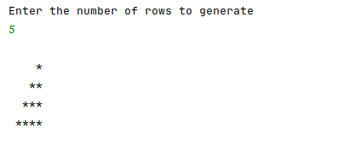

Experiment No. 15
Aim: Write the program to print the following pattern:
1 2 3 4 5 6
2 4 6 8 10 12
3 6 9 12 15 18
4 8 12 16 20 24
5 10 15 20 25 30
6 12 18 24 30 36

Concept Used: loops, nested loops, variables, increment/decrement, printf, conditionals

Program:

#include <stdio.h>

int main() {
int row;
printf("Enter the number of rows to generate\n");
scanf("%d", &row);
for (int i = 1; i <= row; i++) {
for (int j = 1; j <= row; j++) {
printf("%d\t", i * j);
}
printf("\n");
}
}

Output Screenshot:

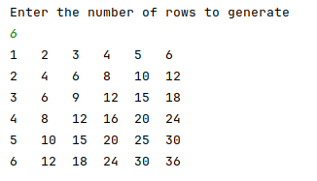
Experiment No. 16
Aim: Write a program to check that the given number is prime, Armstrong or perfect using the concept of functions.

Concept Used: Functions, loops, conditional statements, modular arithmetic, integer exponentiation via loop, return values.

Program:

#include <stdio.h>

int isPrime(int n) {
if (n < 2) return 0;
for (int i = 2; i * i <= n; i++)
if (n % i == 0) return 0;
return 1;
}

int intPow(int base, int exp) {
int result = 1;
for (int i = 0; i < exp; i++)
result *= base;
return result;
}

int isArmstrong(int n) {
int sum = 0, temp = n, digits = 0;
while (temp) {
digits++;
temp /= 10;
}
temp = n;
while (temp) {
int rem = temp % 10;
sum += intPow(rem, digits);
temp /= 10;
}
return sum == n;
}

int isPerfect(int n) {
int sum = 0;
for (int i = 1; i <= n / 2; i++)
if (n % i == 0) sum += i;
return sum == n;
}

int main() {
int num;
printf("Enter number: ");
scanf("%d", &num);
printf("Prime: %s\n", isPrime(num) ? "Yes" : "No");
printf("Armstrong: %s\n", isArmstrong(num) ? "Yes" : "No");
printf("Perfect: %s\n", isPerfect(num) ? "Yes" : "No");
return 0;
}

Output Screenshot:

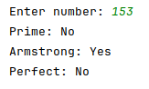

Experiment No. 17
Aim: Write a program to calculate the area and circumference of a circle using functions.

Concept Used: Macros, functions, floating-point arithmetic, return values, input/output, multiplication.

Program:

#include <stdio.h>
#define PI 3.1416

float area(float r) { return PI * r * r; }
float circumference(float r) { return 2 * PI * r; }

int main() {
float radius;
printf("Enter radius: ");
scanf("%f", &radius);
printf("Area = %.2f\n", area(radius));
printf("Circumference = %.2f\n", circumference(radius));
return 0;
}

Output Screenshot:
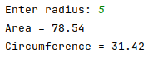

Experiment No. 18
Aim: Write a program to swap two variables using the concept of call by value and call by reference.

Concept Used: Functions, call by value (passing copy), call by reference (using pointers), pointer dereferencing (*), swapping logic with temporary variable, input/output (printf/scanf).

Program:
#include <stdio.h>

void swapByValue(int a, int b) {
int temp = a; a = b; b = temp; // only affects local copies
}
void swapByReference(int *a, int *b) {
int temp = *a; *a = *b; *b = temp;
}
int main() {
int x=5, y=10;
swapByValue(x, y);
printf("After call by value: x=%d, y=%d\n", x, y); // unchanged
swapByReference(&x, &y);
printf("After call by reference: x=%d, y=%d\n", x, y); // swapped
return 0;
}

Output Screenshot:
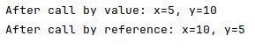

Experiment No. 19
Aim: Write a program to perform the following operations on 1D-Array:
- Insert
- Update
- Delete
- Display
- Search
Concept Used: Arrays (1D), functions, loops (for), array traversal and shifting, insertion/deletion logic, linear search, global variables, input/output (printf).

Program:
#include <stdio.h>
#define MAX 100
int arr[MAX], n = 0;
void insert(int pos, int val) {
for (int i = n; i > pos; i--) arr[i] = arr[i-1];
arr[pos] = val;
n++;
}
void update(int pos, int val) { arr[pos] = val; }
void delete(int pos) {
for (int i = pos; i < n-1; i++) arr[i] = arr[i+1];
n--;
}
void display() {
for (int i = 0; i < n; i++) printf("%d ", arr[i]);
printf("\n");
}
int search(int val) {
for (int i = 0; i < n; i++) if (arr[i] == val) return i;
return -1;
}
int main() {
insert(0, 10); insert(1, 20); insert(1, 15);
display(); // 10 15 20
update(2, 25); display(); // 10 15 25
delete(0); display(); // 15 25
printf("Search 25 at index: %d\n", search(25));
return 0;
}
Output Screenshot:
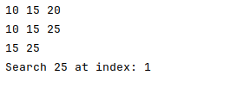
Experiment No. 20
Aim: Write a program to calculate the sum of array elements by passing it to a function.

Concept Used: Arrays, functions, passing arrays to functions (array decay to pointer), loops, sizeof operator, return values, input/output (printf).

Program:

#include <stdio.h>

int sumArray(int arr[], int size) {
int sum = 0;
for (int i = 0; i < size; i++)
sum += arr[i];
return sum;
}

int main() {
int arr[] = {2, 4, 6, 8, 10};
int size = sizeof(arr) / sizeof(arr[0]);
printf("Sum = %d\n", sumArray(arr, size));
return 0;
}

Output Screenshot:

Experiment No. 21
Aim: Write a program to show the use of passing pointer as arguments to the functions.

Concept Used: Pointers, passing pointers as arguments, dereferencing (*), address-of operator (&), functions, modifying variables indirectly.

Program:

#include <stdio.h>

void increment(int *p) {
(*p)++;
}

int main() {
int x = 5;
increment(&x);
printf("x = %d\n", x);
return 0;
}

Output Screenshot:

Experiment No. 22
Aim: Write a program matrix multiplication using the concept of 2D array

Concept Used: 2D arrays, nested loops (triple nested), matrix multiplication logic, array initialization, input/output (printf), using += operator.

Program:
#include <stdio.h>

int main() {
int a[2][2] = {{1,2},{3,4}};
int b[2][2] = {{5,6},{7,8}};
int c[2][2] = {0};

for(int i=0;i<2;i++)
for(int j=0;j<2;j++)
for(int k=0;k<2;k++)
c[i][j] += a[i][k] * b[k][j];

// display result
for(int i=0;i<2;i++){
for(int j=0;j<2;j++)
printf("%d ",c[i][j]);
printf("\n");
}
return 0;
}

Output Screenshot:
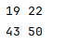

Experiment No. 23
Aim: Write a program matrix multiplication using the concept of 2D array

Concept Used: 2D arrays, nested loops (triple nested), matrix multiplication logic, array initialization, input/output (printf), using += operator.

Program:

